Lab Report (if-else)

1. Temperature Conversion (Centigrade to Fahrenheit)

#include <stdio.h>

int main() {

float c, f;

printf("Enter temperature in Centigrade: ");

scanf("%f", &c);

f = (c \* 9 / 5) + 32;

printf("Temperature in Fahrenheit: %.2f", f);

return 0;

}

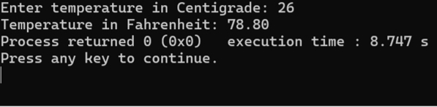

2. Circle Calculations

#include <stdio.h>

#define PI 3.1416

int main() {

float r, d, c, a;

printf("Enter radius of a circle: ");

scanf("%f", &r);

d = 2 \* r;

c = 2 \* PI \* r;

a = PI \* r \* r;

printf("Diameter: %.2f Circumference: %.2f Area: %.2f", d, c, a);

return 0;

}

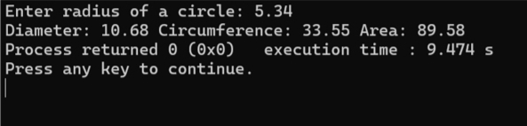

3. Swap Two Numbers Using Third Variable

#include <stdio.h>

int main() {

int a, b, c;

printf("Enter two numbers: ");

scanf("%d %d", &a, &b);

c = a;

a = b;

b = c;

printf("After swapping: a = %d, b = %d", a, b); return 0;

}

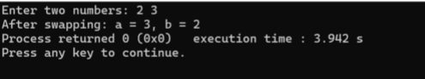

4. Maximum Among Three Numbers

#include <stdio.h>

int main() {

int a, b, c;

printf("Enter three numbers: ");

scanf("%d %d %d", &a, &b, &c);

if(a > b && a > c)

printf("%d is maximum", a);

else if(b > c)

printf("%d is maximum", b);

else

printf("%d is maximum", c);

return 0;

}

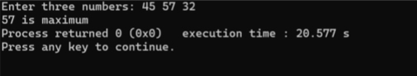

5. Leap Year Check

#include <stdio.h>

int main() {

int year;

printf("Enter a year: ");

scanf("%d", &year);

if((year % 4 == 0 && year % 100 != 0) || year % 400 == 0)

printf("Leap year");

else

printf("Not a leap year");

return 0;

}

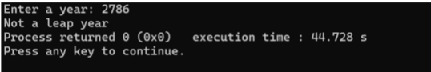

6. Character Type Check

#include <stdio.h>

int main() {

char ch;

printf("Enter a character: ");

scanf("%c", &ch);

if(ch >= 'A' && ch <= 'Z')

printf("Uppercase Alphabet");

else if(ch >= 'a' && ch <= 'z')

printf("Lowercase Alphabet");

else if(ch >= '0' && ch <= '9')

printf("Digit");

else

printf("Special Character");

return 0;

}

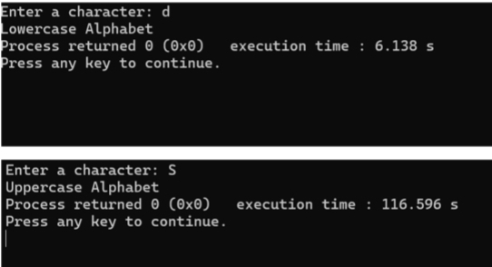

7. Vowel or Consonant

#include <stdio.h>

int main() {

char ch;

printf("Enter an alphabet: ");

scanf("%c", &ch);

if(ch=='a'||ch=='e'||ch=='i'||ch=='o'||ch=='u'|| ch=='A'||ch=='E'||ch=='I'||ch=='O'||ch=='U') printf("Vowel");

else

printf("Consonant");

return 0;

}

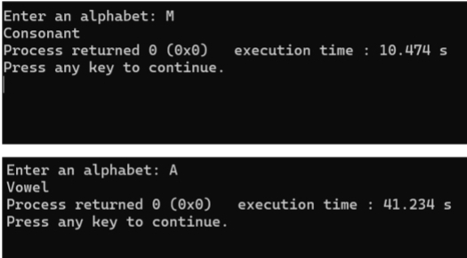

8. Grade Calculation

#include <stdio.h>

int main() {

int marks;

printf("Enter marks: ");

scanf("%d", &marks);

if(marks >= 80)

printf("Grade A+");

else if(marks >= 70)

printf("Grade A");

else if(marks >= 60)

printf("Grade A-");

else if(marks >= 50)

printf("Grade B");

else if(marks >= 40)

printf("Grade C");

else

printf("Grade F");

return 0;

}

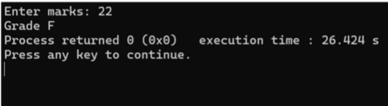

9. Weekday using Switch

#include <stdio.h>

int main() {

int day;

printf("Enter week number (1-7): ");

scanf("%d", &day);

switch(day) {

case 1: printf("Saturday"); break;

case 2: printf("Sunday"); break;

case 3: printf("Monday"); break;

case 4: printf("Tuesday"); break;

case 5: printf("Wednesday"); break;

case 6: printf("Thursday"); break;

case 7: printf("Friday"); break;

default: printf("Invalid input");

}

return 0;

}

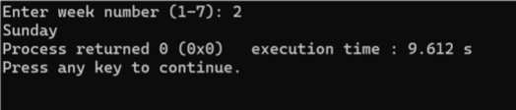

10. Odd or Even Number Check

#include <stdio.h>

int main() {

int num;

printf("Enter a number: ");

scanf("%d", &num);

if(num % 2 == 0)

printf("Even Number");

else

printf("Odd Number");

return 0;

}

